Budget Justification Template
The purpose of this guide is to facilitate the preparation of a budget justification to meet proposal requirements. The Budget Justification describes a budget and budget patterns to Sponsor reviewers who do not have firsthand-knowledge of UNM or your programmatic assumptions. The Budget Justification should be a narrative that explains the necessity and basis for the proposed costs, so there is confidence in the need and reasonableness of the proposed cost.
Tailor the sections below to your project and Sponsor requirements. Your budget justification may not include all of the following categories and may include a category that hasn’t been listed. The budget justification should describe your project’s actual budgetary needs. Make sure to use the most up-to-date rates and percentages as well as links to current University guidance to ensure you have reflected the latest University requirements.
NSF Requirement: Each proposal must contain a budget for each year of support requested. The budget justification must be no more than five pages per proposal. https://www.nsf.gov/pubs/policydocs/pappg18_1/pappg_2.jsp

NIH Requirement: NIH uses two different formats for budget submission depending on the total direct costs requested and the activity code used. You should check the proposal to determine if a detailed or modular budget and justification are needed. https://grants.nih.gov/grants/how-to-apply-application-guide/format-and-write/develop-your-budget.htm

Budget Justification Heading:
Title of Project
Lead PI:
Insert Sponsor’s Solicitation #
(Cayuse #)
Date Prepared
If NIH include – NIH Research Project Grant – (Insert Type: R01, R21, etc.)

Sections:
- Senior/Key Personnel
  - PI -
Dr. Dana Smith, PI (0.5 summer month effort): Dr. Smith serves as Principal Investigator for the <ENTER INFORMATION HERE>. S/he is a Professor of <ENTER DISCIPLINE HERE> and has extensive experience in administration, grants management, and <MORE INFORMATION>. Dr. Smith is an expert in <ENTER MORE INFORMATION HERE>. Her/His primary responsibilities will be to <EXPLAIN THIS PERSON’S ROLE ON THIS PROJECT>, and ensure the completion of all reporting requirements. Compensation is requested for Dr. Smith for 0.50 months during summer 2019 based on a base salary of $5,000/month. Faculty=$2,500. A yearly salary increase of 3% is included.
  - Co-PI-
Dr. <ENTER NAME>, Co-PI (1.0 calendar month effort): Dr. <LAST NAME> is the <DESCRIBE THIS PERSON’S EXPERTISE>. Her/His primary responsibilities for the project will be to < EXPLAIN THIS PERSON’S ROLE ON THIS PROJECT>. A yearly salary increase of 3% is included.
  - Key Personnel -
<ENTER NAME>, Key Personnel (6.0 calendar months effort): <LAST NAME> is the <DESCRIBE THIS PERSON’S EXPERTISE>. Her/His primary responsibilities for the project will be to < EXPLAIN THIS PERSON’S ROLE ON THIS PROJECT>. A yearly salary increase of 3% is included.
- Other Personnel
  - Post-Doctoral Fellow (8.0 calendar months effort):– A Postdoctoral Fellow at $50,000/yr. will contribute 8 calendar months of effort to this project. The Postdoc will oversee the <EXPLAIN THIS PERSON’S ROLES ON THIS PROJECT>. A yearly salary increase of 3% is included.
  - Graduate Research Assistant(s) - (TBD, 9 calendar months effort at 0.50 FTE): <ENTER NUMBER OF GRAs> graduate assistants will make $1500 per month in the academic portion of Year 1 and $3000 per month in the summer. The GRA’s primary responsibilities for the project will be to < EXPLAIN THIS PERSON’S ROLE ON THIS PROJECT>. A yearly salary increase of 3% is included.
  - Undergraduate student(s) - (TBD, 4 calendar months effort at .50 FTE): Four undergraduate assistants will earn $12.00 per hour at .50 FTE during the academic year. The purpose of this position is to provide < EXPLAIN THE ROLES ON THIS PROJECT>. Undergraduate student, who will assist in Project: $12.00/hour X 20 hours/week X 16 weeks (total $3,840) + 1% fringe. A yearly salary increase of 3% is included.
- Fringe Benefits –
The current fringe benefit rates and guidance on when the rates apply can be found on the OSP website at: http://osp.unm.edu/pi-resources/rates.html

**They are updated at least annually. The information below applies to FY19:
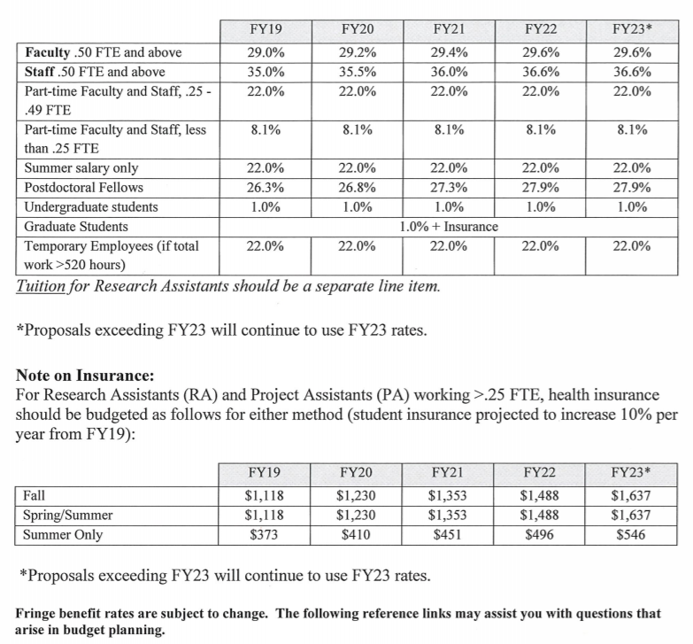
Example:
Fringe benefits are charged at a rate of 22% for Faculty (summer salary only for 9 mo.) 29.2% in year 1, 29.4% in year 2, and 29.6% in year 3, 29.8% in years 4 and 5 for all other Faculty; 35.5%, 36.0%, 36.5%, 37.1%, for Staff; 26.3%, 26.8%, 27.3%, 27.9% for Postdoctoral Fellows and 1% for Graduate Students and Undergraduate Students (8.1% in the summer for students who are taking classes and become part-time staff) incrementing per a table at http://osp.unm.edu/pi-resources/rates.html
Postdoctoral fellows have a higher fringe than 9-month faculty who are paid by the grant in the summer because the former have the insurance benefit that is paid by the grant year-round, while the total faculty insurance benefit is paid during the academic year, the period of the PI’s faculty contract.
Fringe on the graduate salary includes Workman’s Compensation contributions (1% of the student’s salary) are paid from the grant. The PI also is required to pay the graduate assistant’s health insurance from the grant. In the first year, the insurance is $2,032, and that amount is projected to increase at a rate of 10% per year as per a table at http://osp.unm.edu/pi-resources/rates.html

The PI is also required to pay the graduate research assistant’s tuition from the grant (our recommendation based on past experience is an annual increase of 6%). The current rate of $260.62 plus $63.56 <PLUS ANY APPLICABLE TUITION DIFFERENTIAL> is $324.18 per credit hour. (Tuition is excluded from F&A.)
- Capital Equipment - (Equipment is defined as an item with a cost over $5000 and a useful life of over one year. This category is excluded from F&A.) <EXPLAIN WHY THIS PARTICULAR EQUIPMENT IS CRITICAL TO THE SUCCESS OF THE PROJECT.> Obtain prices from vendors and expect the Sponsor may request documentation of the costs. Federal agency sponsors typically have Buy American requirements.
- Travel (Explain the purpose of the trip(s) and how the travel will benefit the project.)
Domestic:
We request travel support for the PI and the graduate student(s) per year to attend a <LIST NAMES OF MEETINGS AND CONFERENCES IF KNOWN> at which we will <EXPLAIN THE PURPOSE OF THE TRIP(S) AND HOW THE TRAVEL WILL BENEFIT THE PROJECT.>

(SAMPLE)
2 travelers to <MEETING NAME> | Year 1  Seattle | Year 2  Chicago | Year 3  Baltimore | Year 4  <Destination> | Year 5  <Destination>
Airfare: $600/ person | $1,200 | None | $1,200 | $1,200 | $1,200
Per Diem: $115 per day * 3 days * 2 travelers | $690 | None | $690 | $690 | $690
Lodging: $150 per night * 2 nights * 2 travelers | $600 | None | $600 | $600 | $600
Transportation: $85 per day * 3 days * 2 travelers | $510 | None | $510 | $510 | $510

Foreign: (Review the solicitation to verify the Sponsor permits foreign or international travel.)
We request travel support for the PI and the graduate student(s) per year to attend a <LIST NAMES OF MEETINGS AND CONFERENCES IF KNOWN> at which we will <EXPLAIN THE PURPOSE OF THE TRIP(S) AND HOW THE TRAVEL WILL BENEFIT THE PROJECT.>

(SAMPLE)
2 travelers to <MEETING NAME> | Year 1  Brazil | Year 2  Vancouver | Year 3  <Destination> | Year 4  <Destination> | Year 5  <Destination>
Airfare: $600/ person | $1,200 | None | $1,200 | $1,200 | $1,200
Per Diem: $115 per day * 3 days * 2 travelers | $690 | None | $690 | $690 | $690
Lodging: $150 per night * 2 nights * 2 travelers | $600 | None | $600 | $600 | $600
Transportation: $85 per day * 3 days * 2 travelers | $510 | None | $510 | $510 | $510
Note: All travel costs are based on historical actuals or current GSA per-diem rates, from https://www.gsa.gov/travel-resources. Proposed travel cost will use current rates as they are available.
- Participant Support Costs Direct costs for items such as stipends or subsistence allowances, travel allowances, and registration fees paid to or on behalf of participants or trainees (BUT NOT EMPLOYEES) in connection with conferences, or training projects. This category is excluded from F&A. <EXPLAIN THE PROPOSED ACTIVITIES AND HOW MANY PARTICIPANTS ARE EXPECTED TO ATTEND.>
- Other Direct Costs
Materials and Supplies: <DESCRIBE THE MATERIALS AND SUPPLIES PROPOSED AND HOW THE PROJECT BENEFITS FROM THE ITEMS PROPOSED. DESCRIBE THE METHOD USED TO ESTIMATE THESE COSTS AND HOW ESCALATED IN MULTI-YEAR BUDGETS.>

Subawards/subcontracts: (Indicate the portion of the technical or programmatic effort that will be performed by the subawardee. F&A is charged on the first $25,000 of each subaward.) A subaward has been planned with <NAME OF SUBAWARD ORGANIZATION> based on their recognized scholarly excellence and facilities in the area of <ADD DETAIL>. The total sub-award amount is <$AMOUNT>.
NSF Requirement: For proposals that contain a subaward(s), each subaward must include a separate budget justification of no more than five pages. See Chapter II.C.2.g.(vi)(e) for further instructions on proposals that contain subawards.
Consultant Services: (UNM faculty and staff cannot be paid as consultants.) <NAME> is the <DESCRIBE THIS PERSON’S EXPERTISE>. Her/His primary responsibilities for the project will be to <WORK DESCRIPTION AND RELEVANCE TO THE SUCCESS OF THE PROJECT, DAILY RATE OF PAY, NUMBER OF DAYS OF WORK, AND COSTS OF TRAVEL, IF ANY.>

Publication Costs: <ESTIMATED BASED ON PAGE RATES FOR JOURNALS OR PI’S EXPERIENCE WITH SIMILAR PUBLICATIONS AND RELATED ESCALATION.>
Other: (Include all other direct costs which do not fall into other categories, such as: computers and other non-capital equipment, lab service fees, advertising, books, etc.) (Computers – when included in the budget, describe how they directly benefit the project and assurance that they will be used exclusively on the project.)

NSF Requirement: NSF requires the following types of expenses to be included in this category: incentive payments “human subject payments,” fees for speakers and trainers, costs related to sponsor funded conferences such as room rental fees, catering, and supplies.

- Indirect Costs or Facilities and Administration Costs (F&A)*: the Federally negotiated F&A rate for a grant to the University of New Mexico is 51.5% on Modified Total Direct Costs. This percentage is not applied to capital equipment (cost exceeding $5000), to participant support costs, or to tuition expenses. F&A is charged on the first $25,000 of each subaward’s paid invoices. UNM’s indirect cost rates in this proposal include predetermined and provisional rates. The F&A rate agreement can be found at http://osp.unm.edu/pi-resources/rates.html.

*For DOD proposals, we recommend you budget the F&A at the 54% rate unless the solicitation states the award mechanism will be a grant. At the time the award is received, the F&A rate will be adjusted (per our F&A rate agreement) to match the award mechanism received, i.e. grant or contract.

